Strategy 1:

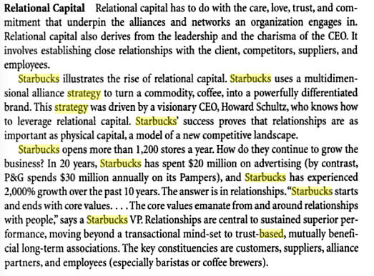

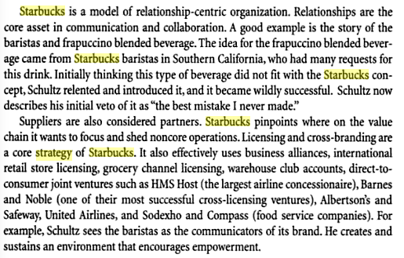

Strategy 2:

Capabilities:

Functional area

#Supply Chain Distribution: effective procurement techniques